**Learning Firebase - Comprehensive Guide**

**Table of Content:**

**1. Introduction**

**2. Prerequisites**

**3. Firebase Overview**

**4. Setting up Firebase Project**

**5. Authentication**

**6. Fire store Database**

**7. Firebase Storage**

**8. Cloud Functions**

**9. Firebase Hosting**

**10. Cloud Messaging**

**11. Security Rules**

**12. Testing and Debugging**

**13. Advanced Topics**

**14. Best Practices**

**15. Resources**

**16. Demo Project**

* **Created Under guidance Of Nilesh Prajapati.**
* **Level of Document: Basic / Intermediate.**
* **Outcome: Basic understanding of Firebase and able to create a basic project.**

**Introduction:**

* Welcome to the comprehensive guide for learning Firebase! Firebase, developed by Google, is a robust platform for building web and mobile applications. This guide is designed for both beginners and experienced developers seeking to enhance their skills in Firebase. It covers essential concepts, setup procedures, and resources to master Firebase development.

**Prerequisites:**

* Before diving into Firebase, ensure you have a solid understanding of the following:
* Basic HTML/CSS
* JavaScript Fundamentals
* Node.js and npm
* ReactJs <https://github.com/nil-01/ReactjsBasic> (For Demo)
* Account on firebase.

**Firebase Overview:**

* Firebase offers a comprehensive set of tools and services, including real-time database, authentication, cloud functions, hosting, and more. It simplifies the development process and enhances the functionality of your applications.
* **Pros:**
* It is simple and user friendly. No need for complicated configuration.
* The data is real-time, which means that every change will automatically update connected clients.
* Firebase offers simple control dashboard.
* There are a number of useful services to choose.
* **Cons:**
* Firebase free plan is limited to 50 Connections and 100 MB of storage.

**Setting Up Firebase Project:**

1. **Creating a Firebase Project:**
   * Visit the **Firebase Console (**<https://console.firebase.google.com/>).

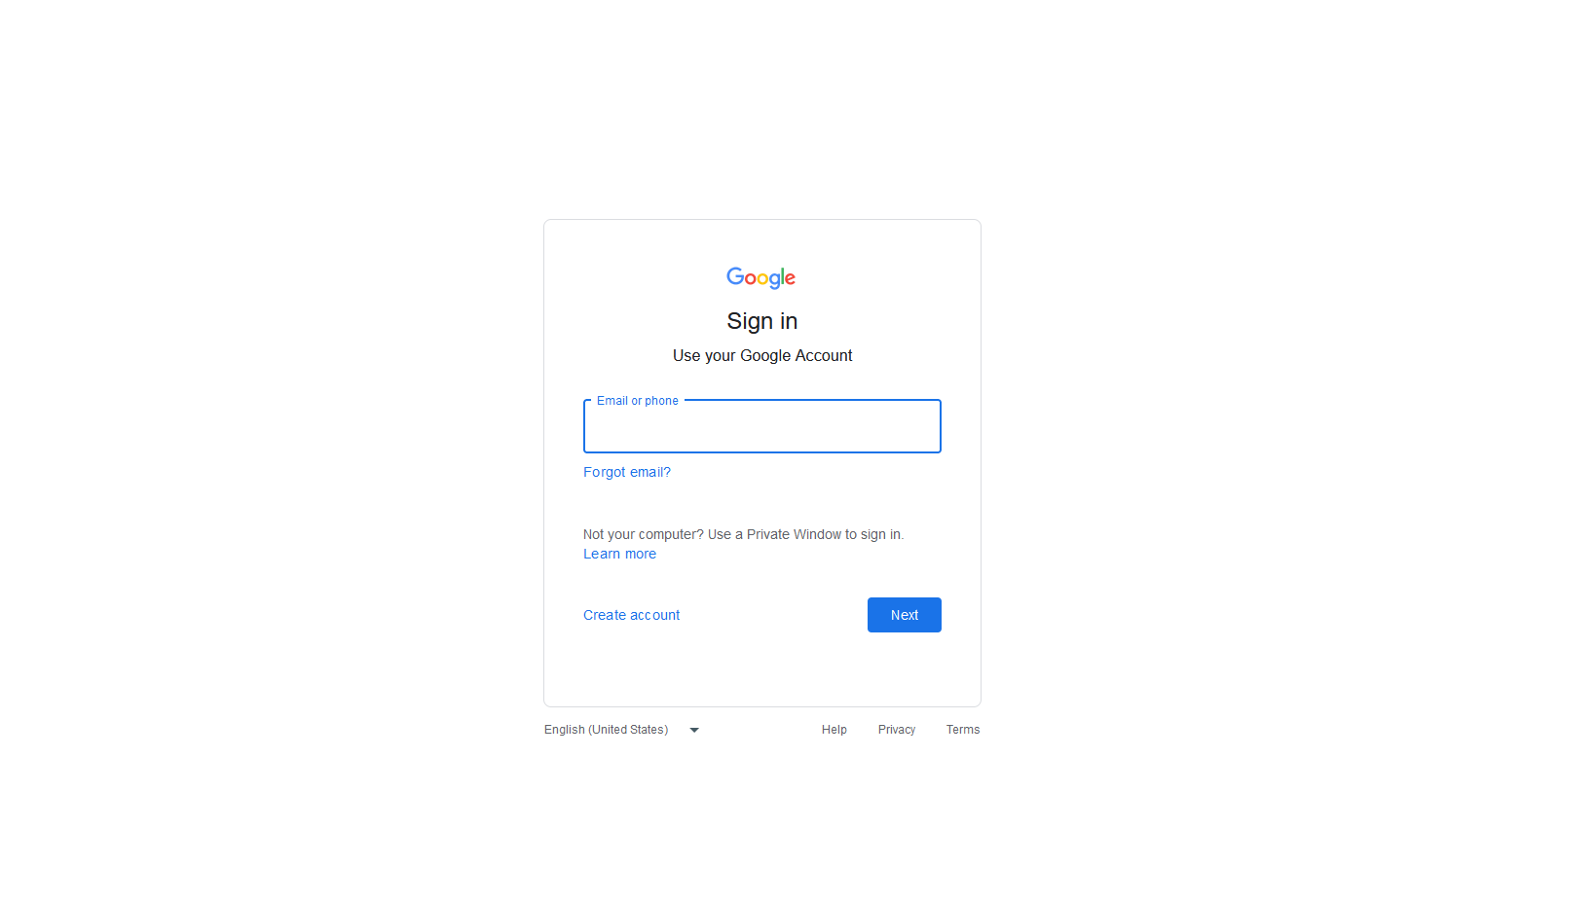

* + Sign Up Or Sign In (Note : If you already login in your browser this pop up will not come)
  + If you are already login in browser with Google account you will redirect to this page.

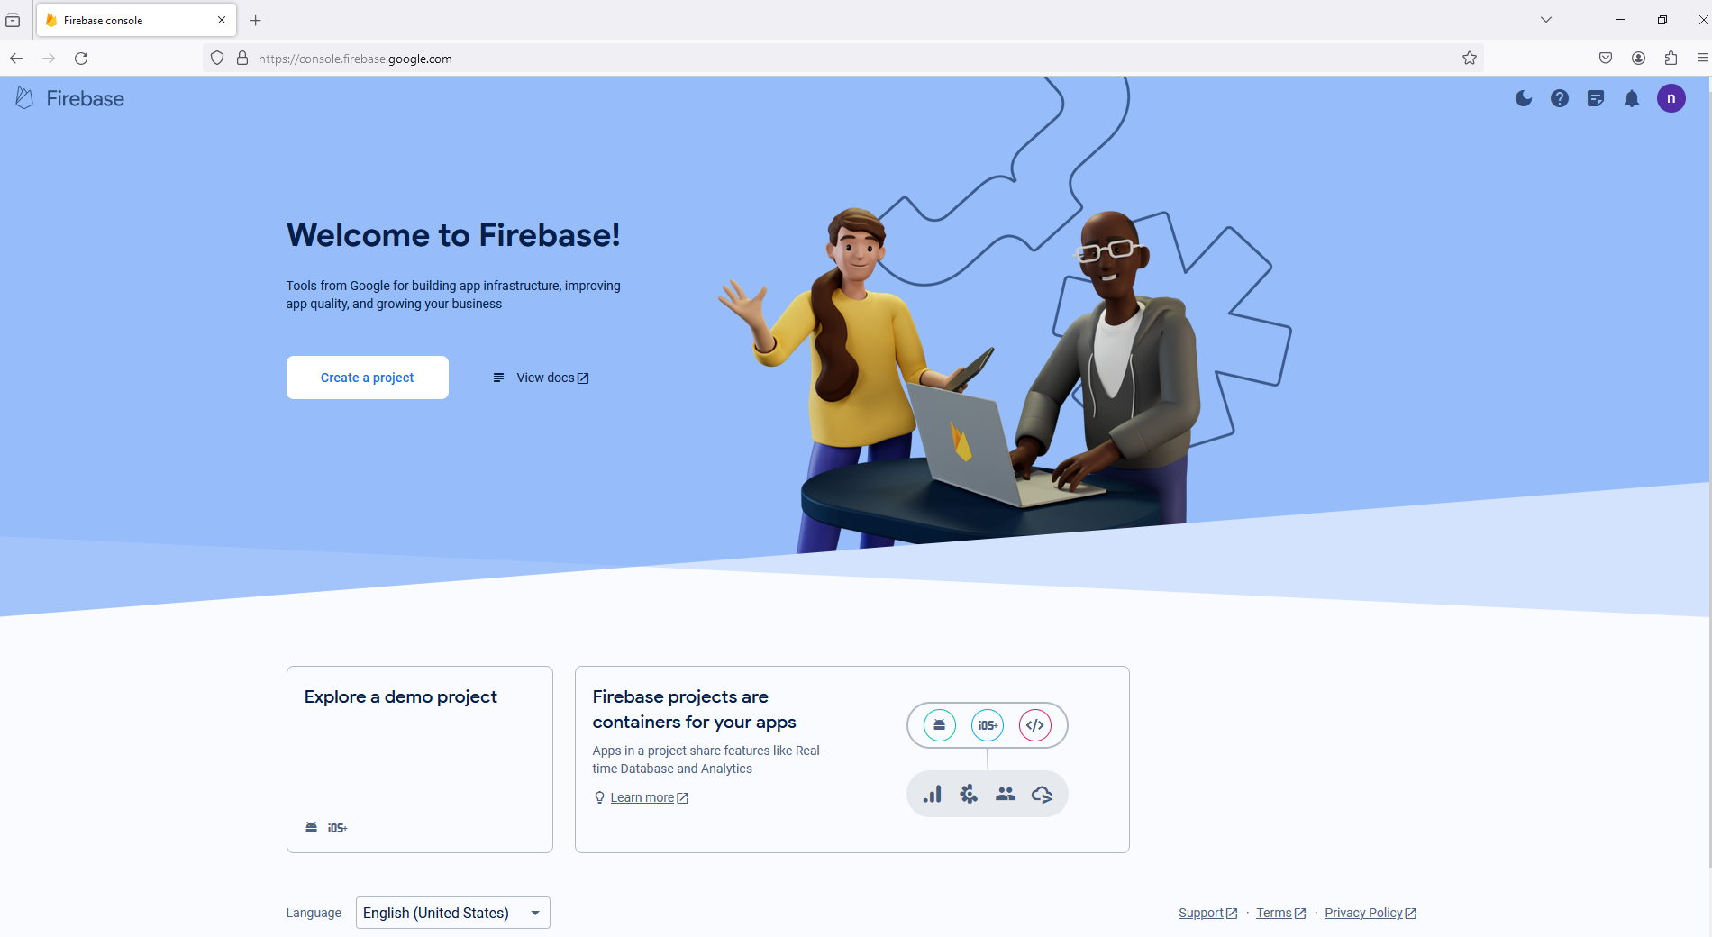

* + Click on "Create a Project" and follow the setup instructions.

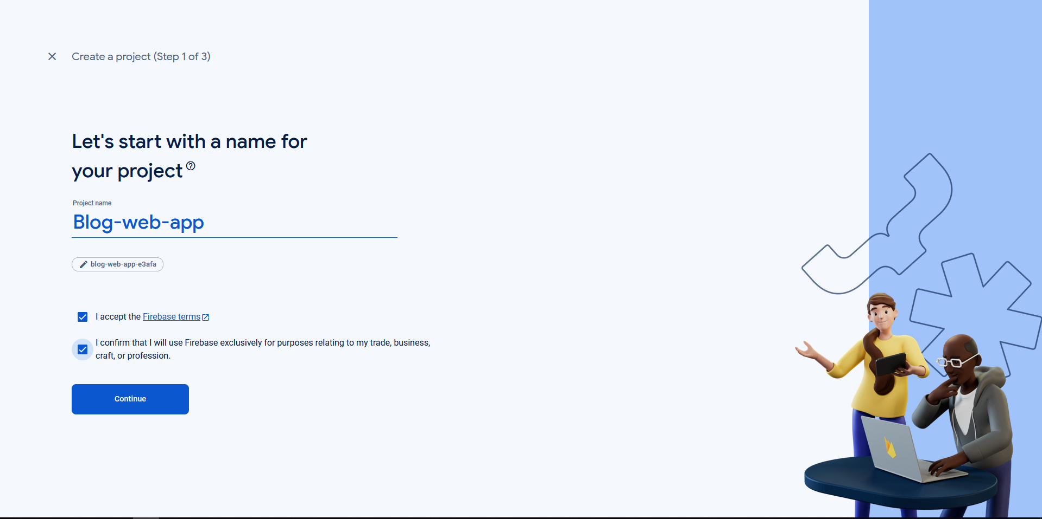

* + Click on Continue and you will redirect to next page.

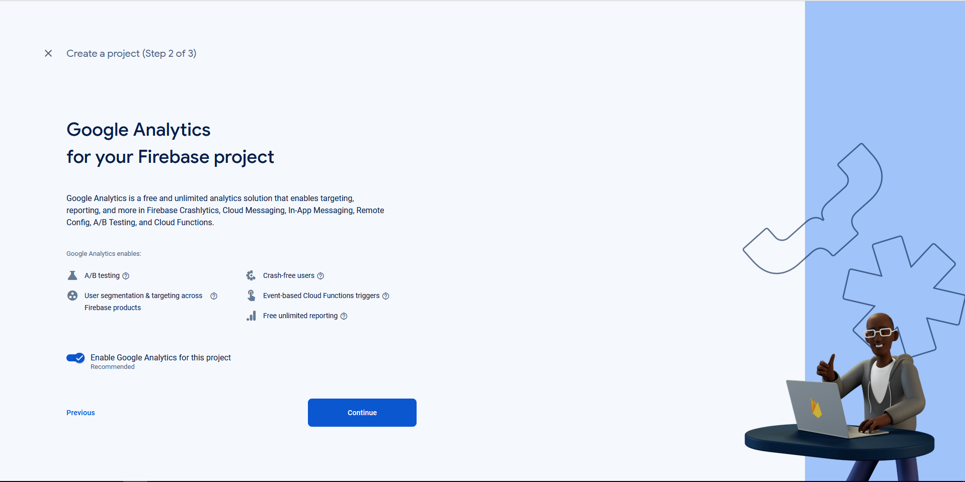

* + Click on Continue and you will redirect to next page.



* + Click on Continue and you app is created.
  + After now your dashboard look as below.

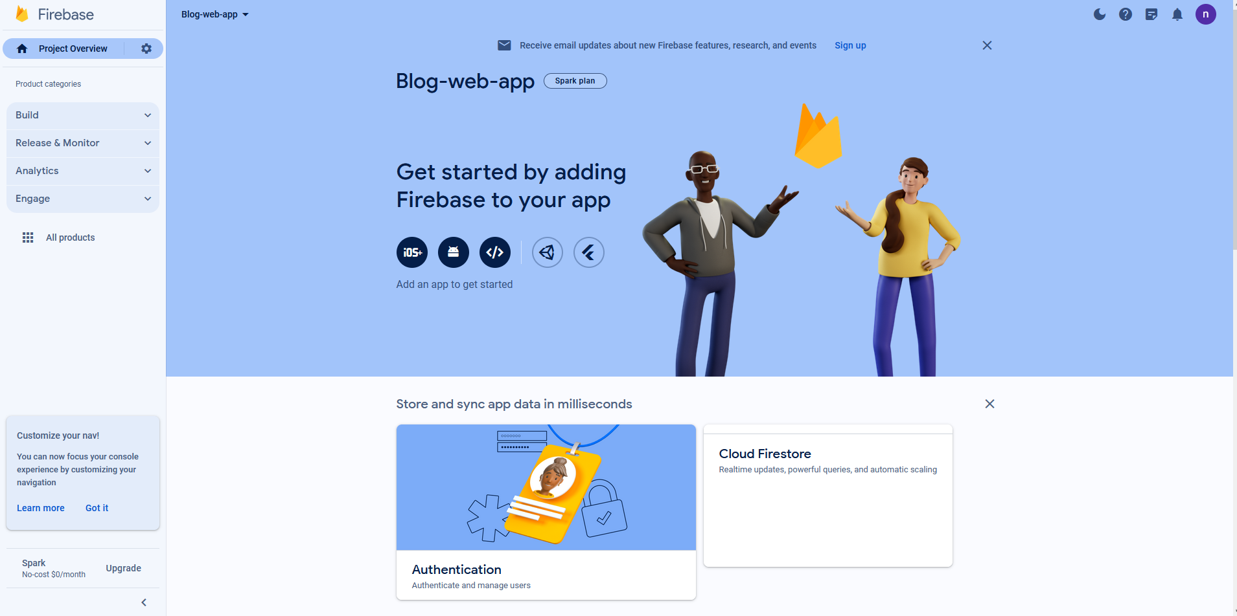

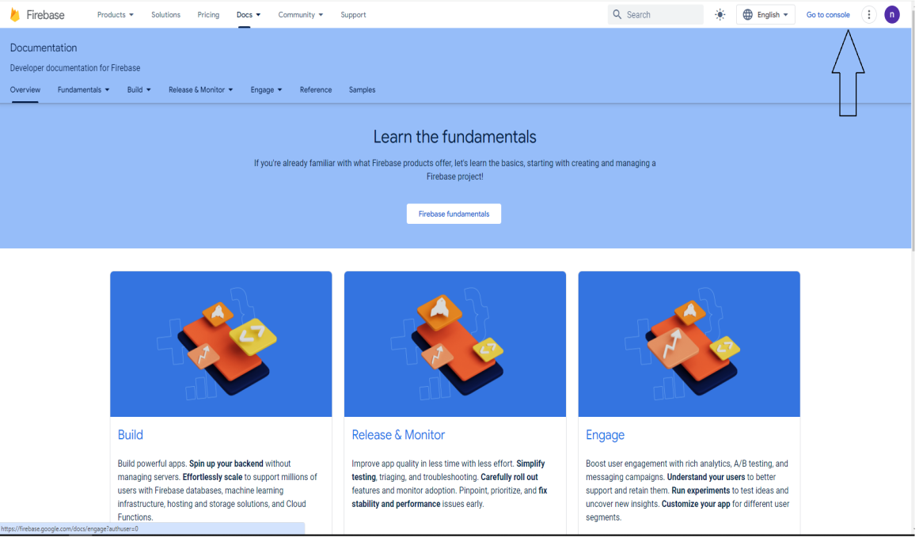

1. Adding Firebase to your Web App:

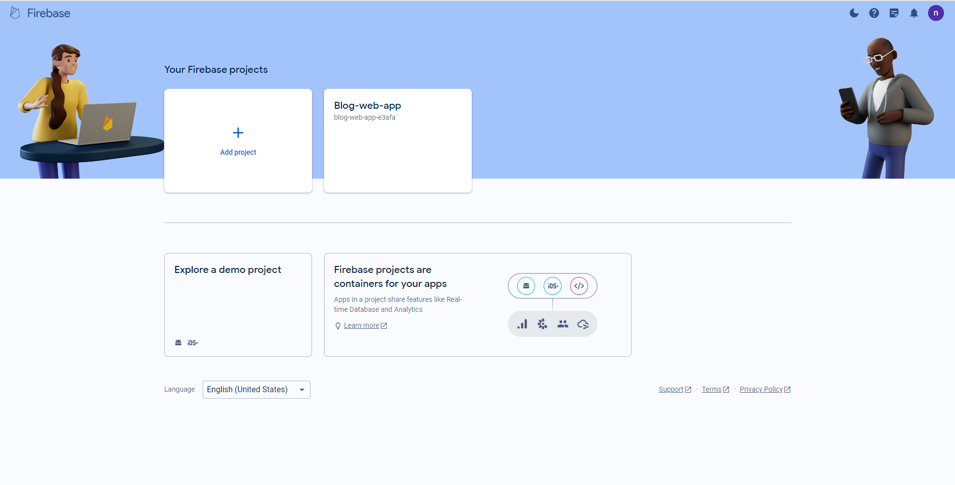

* In the Firebase Console, select your project.

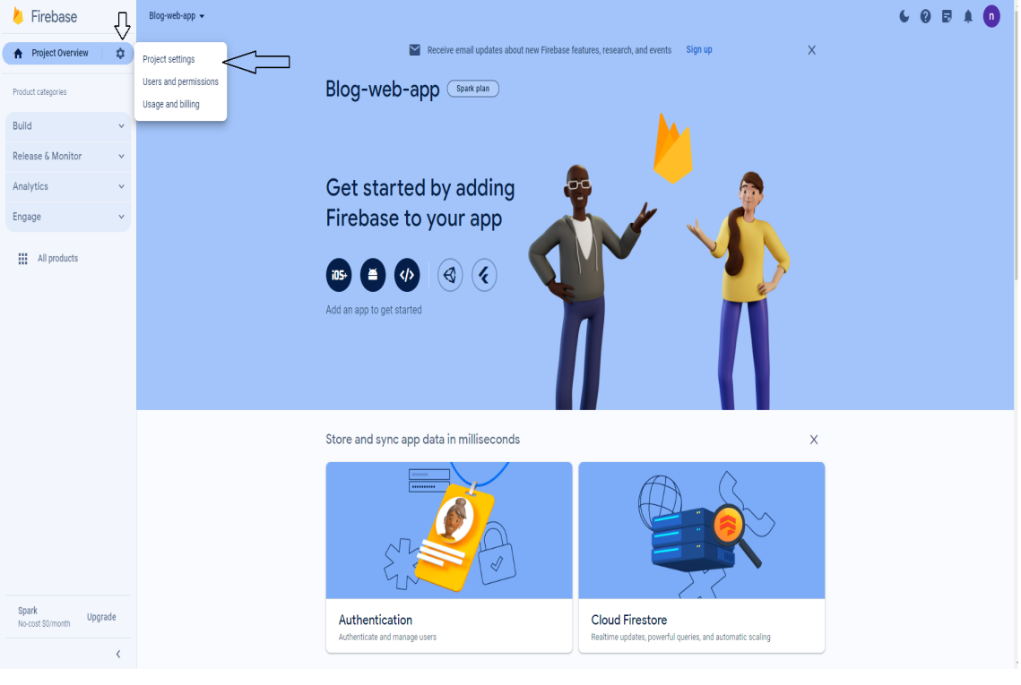

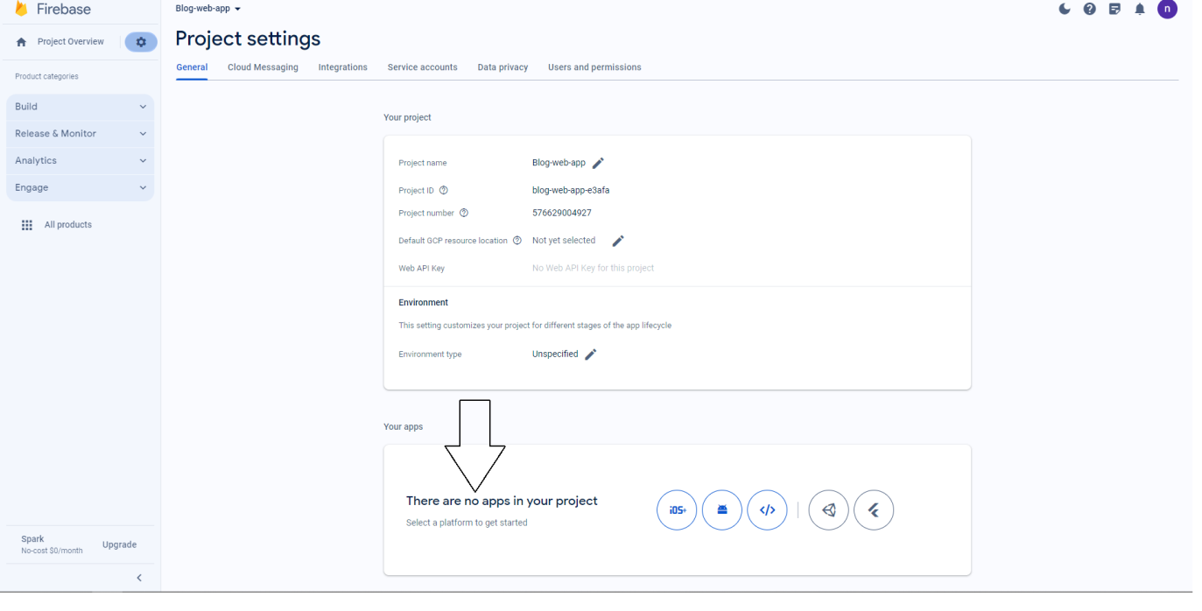

* Note if you find tab like this that not app found then click on web tab as shown below you can select based on your choice but here I am developing with web app so I am going with web.

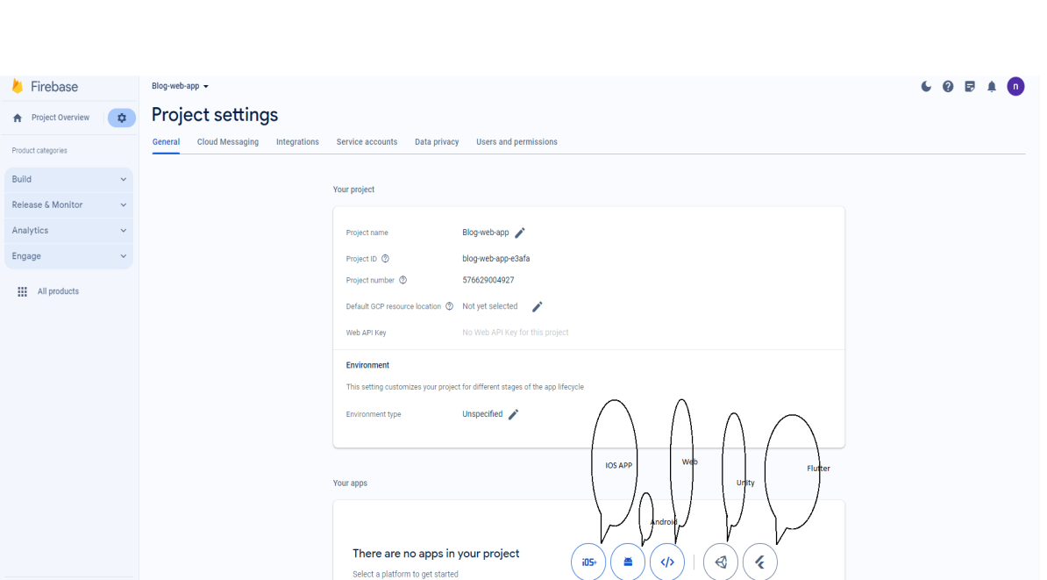

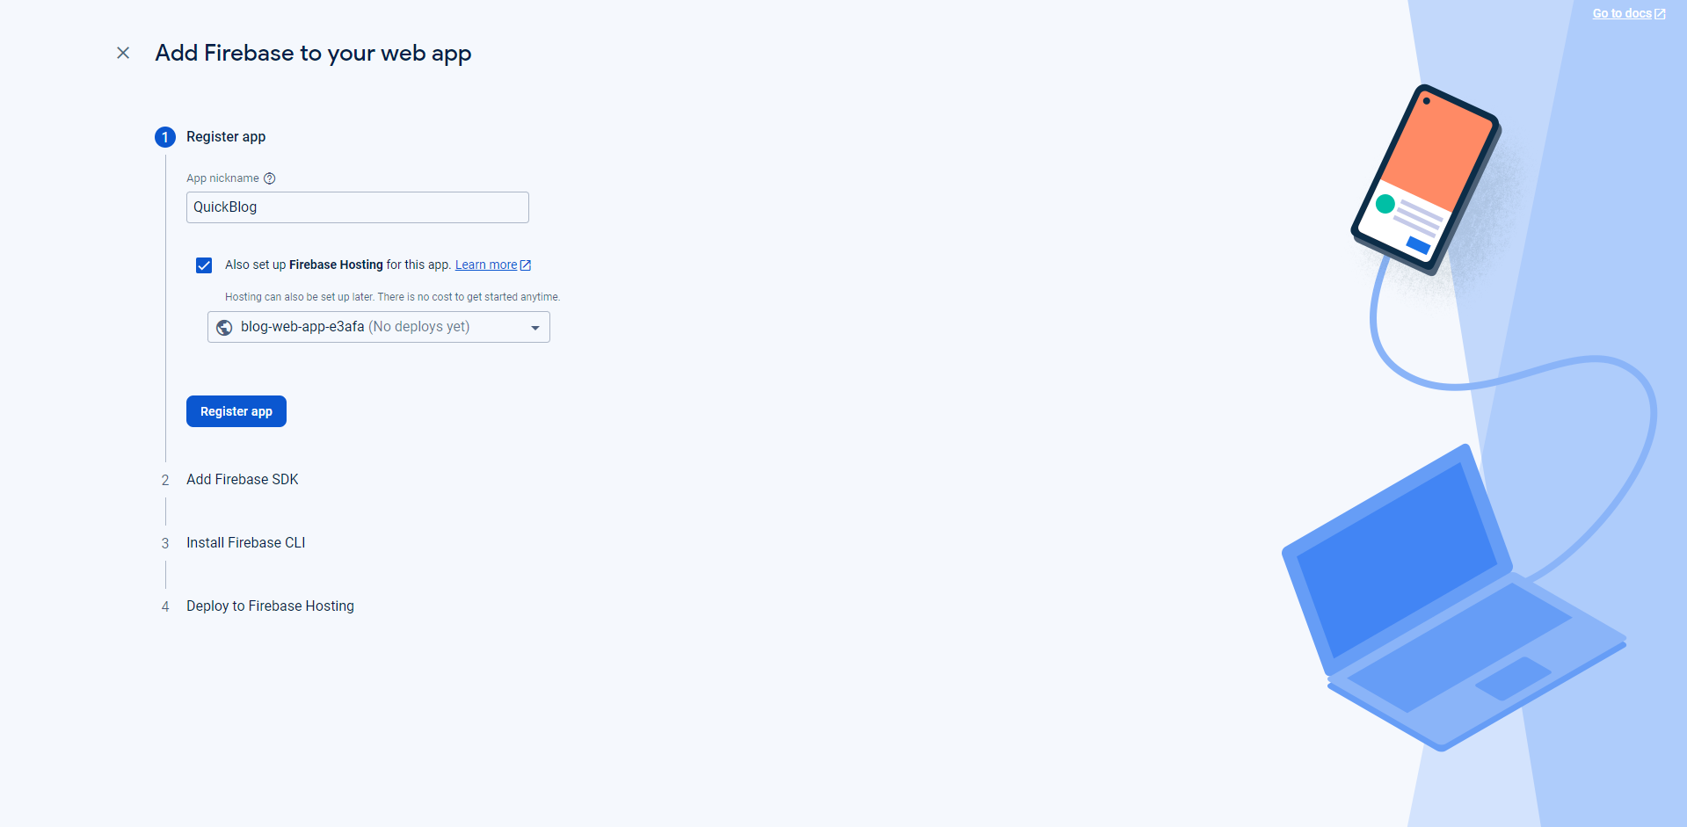

* Write name of your own choice for app and click on register app.

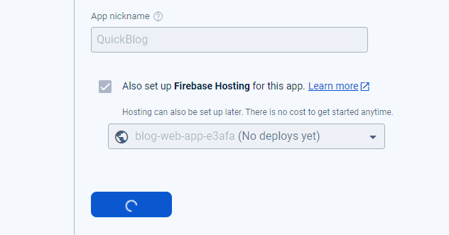

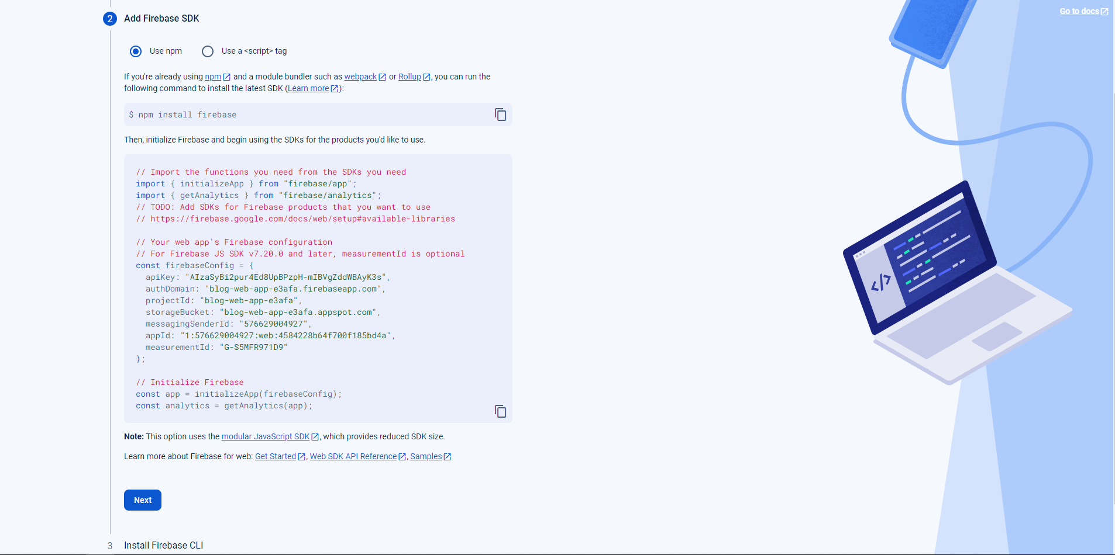

* Click next and we will understand about the code written in demo.

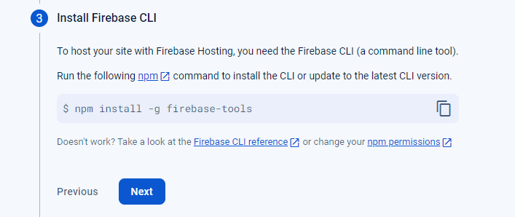

* Click next and command shown in above image is for installing the tool globally it is mainly used when we deploy our project.
* Click on continue to console and you are ready with project creation and app creation and set up with firebase setup.

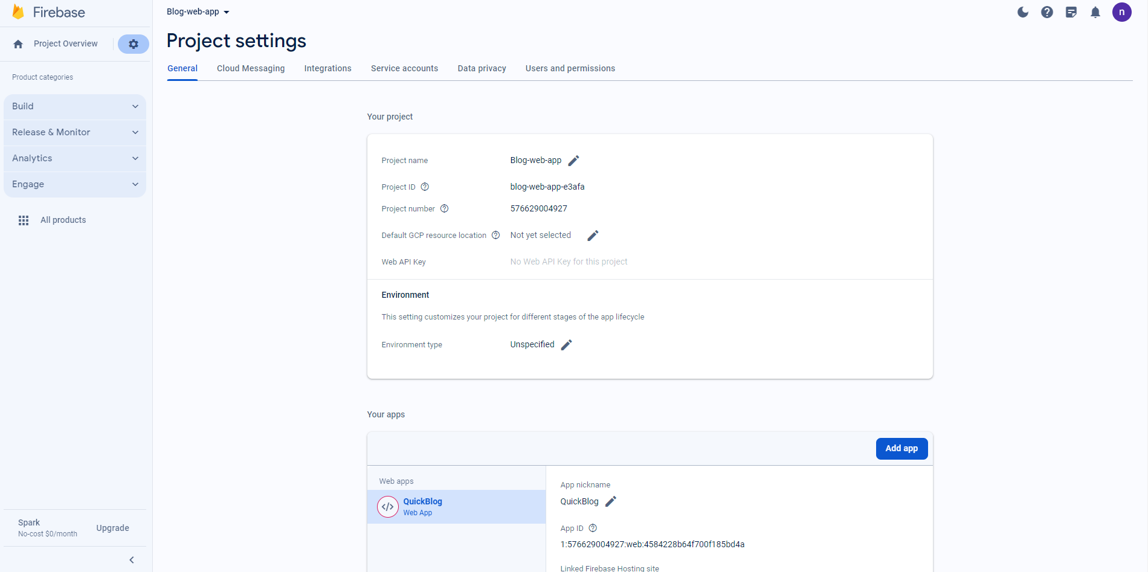

* You will able to see your app now in general tab.

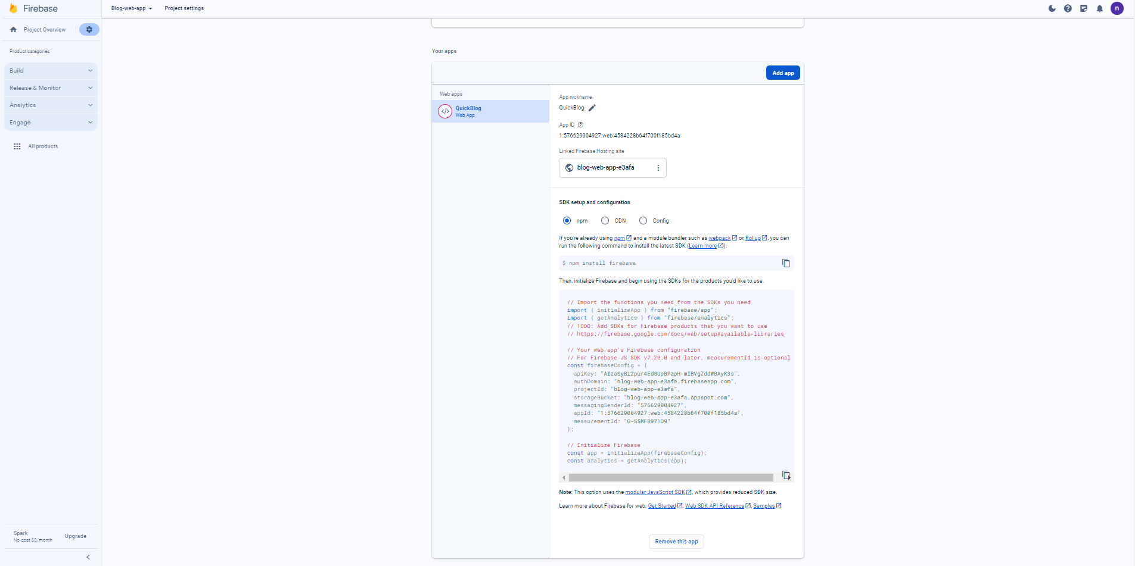

* Go to Project settings, and under the General tab, find your app's configuration.
* Copy the configuration and add it to your web app.
* Before configuring firebase app set up in our web app project let us get familiar with the firebase tool and its feature.

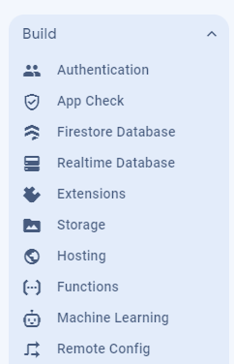

**Authentication:**

* Firebase Authentication provides secure sign-in methods, including email/password, Google, Facebook, etc. Implement user authentication to enhance the security of your application.
* [Click me to learn more about me](https://firebase.google.com/docs/auth/?sjid=15586894813222994432-AP).

**Fire store Database:**

* Firestore is a NoSQL document database that enables real-time data synchronization. Learn data modeling, querying, and real-time updates for building dynamic applications.
* [Click me to learn more about me](https://firebase.google.com/docs/firestore/rtdb-vs-firestore).

**Firebase Storage:**

* Firebase Storage allows you to store and serve user-generated content, such as images or videos. Integrate Firebase Storage to handle media assets in your application.
* [Click me to learn more about me](https://firebase.google.com/docs/storage).

**Cloud Functions:**

* Use Cloud Functions to run server-side code in response to events triggered by Firebase features or HTTP requests. Explore server less architecture and automate backend processes.
* [Click me to learn more about me.](https://firebase.google.com/docs/functions)

**Firebase Hosting:**

* Firebase Hosting provides a platform to deploy and host your web applications. Learn to deploy your app easily and ensure a seamless user experience.
* [Click me to learn more about me.](https://firebase.google.com/docs/hosting/use-cases)

**Cloud Messaging:**

* Firebase Cloud Messaging (FCM) enables push notifications for your app. Implement push notifications to engage users and keep them informed.
* [Click me to learn more about me.](https://firebase.google.com/docs/cloud-messaging)

**Security Rules:**

* Firebase Security Rules control access to your data and resources. Understand how to write effective security rules to protect your application.
* [Click me to learn more about me.](https://firebase.google.com/docs/rules)

**Testing and Debugging:**

* Learn effective strategies for testing and debugging Firebase applications. Ensure the reliability and performance of your app through thorough testing.
* [Click me to learn more about me](https://firebase.google.com/docs/app-check).

**Advanced Topics:**

* Explore advanced Firebase topics, including machine learning with Firebase ML Kit, A/B testing, and performance monitoring. Unlock additional functionalities to enhance your applications.
* [Click me for ML learning](https://firebase.google.com/docs/ml).
* [Click me to learn about test lab.](https://firebase.google.com/docs/test-lab)
* [Click on me to learn query writing in firebase.](https://firebase.google.com/docs/firestore/query-data/queries)
* [Click me to learn about my pricing.](https://firebase.google.com/pricing)

**Best Practices:**

* Adopt best practices for Firebase development:
* Modularization: Keep Firebase services modular and focused on specific tasks.
* Data Security: Implement strong security rules to protect user data.
* Real-time Updates: Leverage real-time features for dynamic and responsive applications.
* Code Structure: Maintain a clean and organized code structure for scalability.

**Resources:**

Explore additional resources to deepen your understanding of Firebase:

* **Community Resources:**
* Firebase Documentation(<https://firebase.google.com/docs>)
* Firebase GitHub Repository(<https://github.com/firebase>)
* Firebase Blog(<https://firebase.googleblog.com/)>
* Firebase YouTube Channel(<https://www.youtube.com/user/Firebase>)
* **Other Resources:**
* Fire base by Pedro Tech **(Video):** [**https://www.youtube.com/watch?v=fgdpvwEWJ9M**](https://www.youtube.com/watch?v=fgdpvwEWJ9M)
* **Fire base integration with ReactJs by nil (Docs + Demo)**

[**https://github.com/nil-01/FirebaseLearning**](https://github.com/nil-01/FirebaseLearning)